Current Operable Unit 3 Remedial Progress for Week Ending 1/22/10
Creamer Environmental Inc., National Grid’s Remediation Contractor, is continuing to excavate and backfill where the LIRR tracks were relocated. To date 150 trucks have transported approximately 4054.77 tons (2703.18 cubic yards) of soil to Bay Shore Soil Management (formerly ESMI of NJ) for thermal desorption. Additionally 66,813 gallons of impacted excavation water has been disposed of at Clean Waters of Staten Island and Bridgeport United Recycling in Connecticut. Excavation and load out of Cells 4 and 5 were completed this week.
GEI, National Grid’s Remediation Oversight Consultant, continues to perform CAMP (Community Air Monitoring Program), Noise and Vibration monitoring. CAMP, Noise and Vibration monitoring will continue throughout the project.

Two-Week Outlook
Excavation and load out of cells 6 and 7 will begin on 1/25/10. Following the remaining excavation and backfill phase, Creamer Environmental will start the restoration phase which will include the re-construction of the original LIRR track alignment and site restoration. Phase 1 is anticipated to continue until mid to late February.
General hours of operation will continue to be Monday through Friday, 7:00 AM to 3:30 PM. However, work hours will be extended when necessary to maintain schedule or to complete critical tasks.

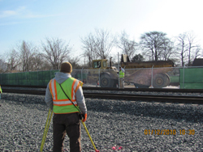
Monitoring LIRR track elevation
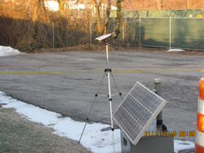
Noise and vibration monitors

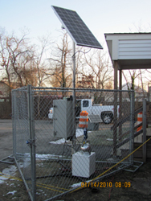
1 of 4 CAMP monitoring stations

